**Lego Challenge**

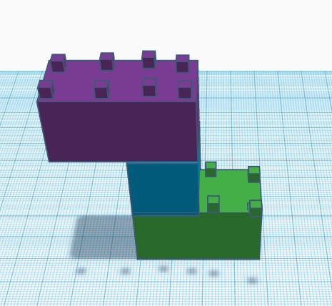

My partner and I did alright in this task. The shape isn’t perfect, but it is almost right. Knowing that we were using Legos made it easier to think about the shape that the blocks should be as most Legos are cubes or cuboids. Knowing how many studs each Lego had would have made it easier to know the dimensions. It was hard to build when everyone else was talking but I think we had good communication skills. It was hard to position the studs in the right place because it looks different at different angles. If I were to do this again, I would ask for the number of studs on each brick and use north, south, east and west for directions. I would also spend more time on positioning the different blocks.